

*java iot developer Lab*

Lab -4

**SUBMITTED BY: SUBMITTED TO:**

**AYUSH KUMAR JHA Dr. SURBHI SARASWAT**

**SAP ID - 500086400**

**Enrollment no - R200220083**

**B.C.A -I.O.T.**

Questions :-

1.Make a delay for half a second for one LED.

// C++ code

//

int buttonState = 0;

void setup()

{

pinMode(2, INPUT);

pinMode(8, OUTPUT);

}

void loop()

{

// read the state of the pushbutton value

buttonState = digitalRead(2);

// check if pushbutton is pressed. if it is, the

// buttonState is HIGH

if (buttonState == HIGH) {

// turn LED on

delay(500);

digitalWrite(8, HIGH);

} else {

// turn LED off

digitalWrite(8, LOW);

}

// Delay a little bit to improve simulation performance

delay(10);

}

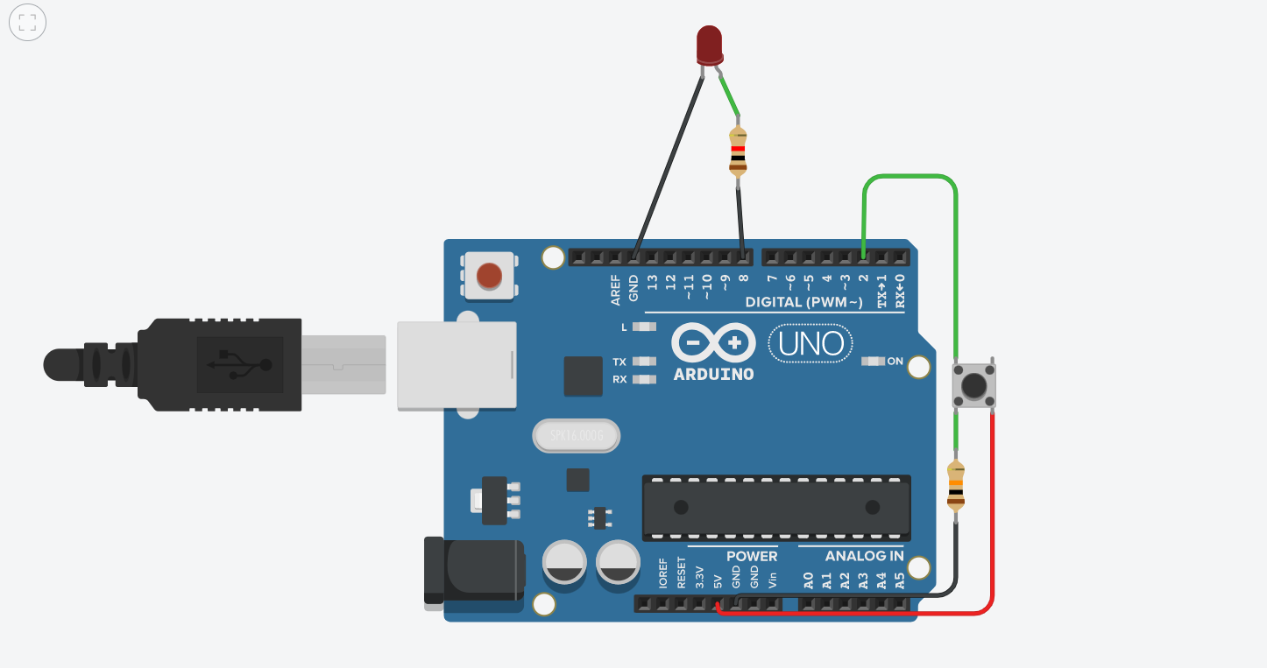

2.Add 3 LED make them blink at the count of 1 2 3.

// C++ code

//

int buttonState = 0;

void setup()

{

pinMode(2, INPUT);

pinMode(8, OUTPUT);

pinMode(9, OUTPUT);

pinMode(10, OUTPUT);

}

void loop()

{

// read the state of the pushbutton value

buttonState = digitalRead(2);

// check if pushbutton is pressed. if it is, the

// buttonState is HIGH

if (buttonState == HIGH) {

// turn LED on

delay(500);

digitalWrite(10, HIGH);

delay(500);

digitalWrite(10,LOW);

delay(500);

digitalWrite(9,HIGH);

delay(500);

digitalWrite(9,LOW);

delay(500);

digitalWrite(8,HIGH);

delay(500);

digitalWrite(8,LOW);

delay(500);

} else {

// turn LED off

digitalWrite(8, LOW);

digitalWrite(9,LOW);

digitalWrite(10,LOW);

}

// Delay a little bit to improve simulation performance

delay(10);

}

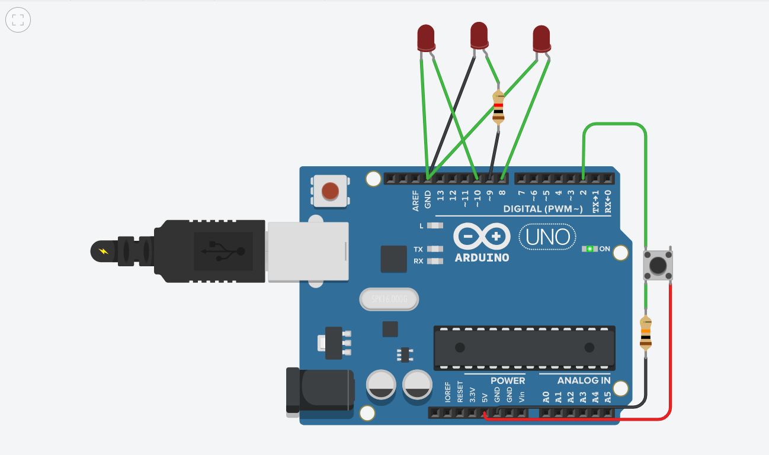

3.Make a dancing LED configuration.

// C++ code

//

int buttonState = 0;

void setup()

{

pinMode(2, INPUT);

pinMode(11, OUTPUT);

pinMode(9, OUTPUT);

pinMode(10, OUTPUT);

pinMode(12, OUTPUT);

pinMode(13, OUTPUT);

}

void loop()

{

// read the state of the pushbutton value

buttonState = digitalRead(2);

// check if pushbutton is pressed. if it is, the

// buttonState is HIGH

if (buttonState == HIGH) {

// turn LED on

delay(500);

digitalWrite(13, HIGH);

delay(500);

digitalWrite(13,LOW);

delay(500);

digitalWrite(12,HIGH);

delay(500);

digitalWrite(12,LOW);

delay(500);

digitalWrite(11,HIGH);

delay(500);

digitalWrite(11,LOW);

delay(500);

digitalWrite(10,HIGH);

delay(500);

digitalWrite(10,LOW);

delay(500);

digitalWrite(9,HIGH);

delay(500);

digitalWrite(9,LOW);

delay(500);

} else {

// turn LED off

digitalWrite(11, LOW);

digitalWrite(9,LOW);

digitalWrite(10,LOW);

digitalWrite(12,LOW);

digitalWrite(13,LOW);

}

// Delay a little bit to improve simulation performance

delay(10);

}

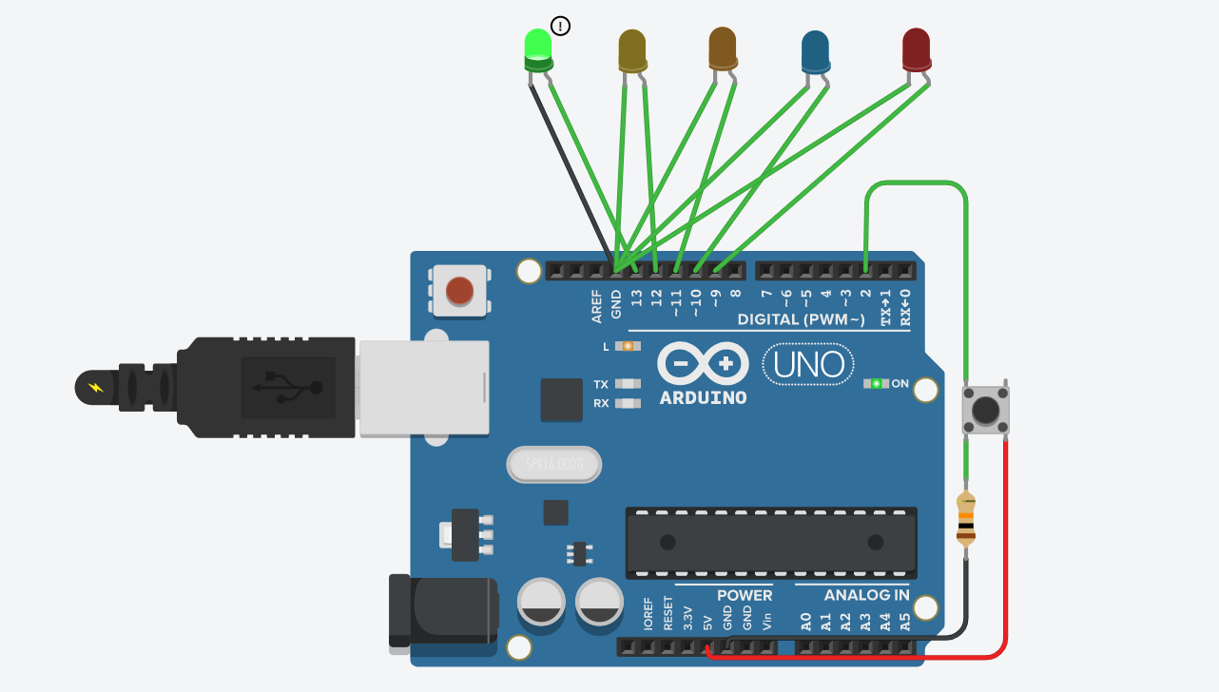

4.Add RGB LED and test FIVE different colour scheme configuration

void setup() {

pinMode(11, OUTPUT);

pinMode(10, OUTPUT);

pinMode(9, OUTPUT);

}

void loop() {

RGB_color(255, 0, 0); // Red

delay(1000);

RGB_color(0, 255, 0); // Green

delay(1000);

RGB_color(0, 0, 255); // Blue

delay(1000);

RGB_color(255, 255, 125); // Raspberry

delay(1000);

RGB_color(0, 255, 255); // Cyan

delay(1000);

RGB_color(255, 0, 255); // Magenta

delay(1000);

RGB_color(255, 255, 0); // Yellow

delay(1000);

RGB_color(255, 255, 255); // White

delay(1000);

}

void RGB_color(int red_light_value, int green_light_value, int blue_light_value)

{

analogWrite(11, red_light_value);

analogWrite(10, green_light_value);

analogWrite(9, blue_light_value);

}

